“Martial Arts Club “

Name: MOE KHANT ZAW

Section: HND 34

Subject: computing project

Contents

1 Current Business history 4

1.2 Current business process 5

1.2.1 Registration management 5

1.2.2 Attending management 5

1.2.3 Class and section management 5

1.2.5 Exam management 6

1.2.6 Payment tracking 6

1.2.8 Fund management 6

1.2.9 Tournament management 6

1.3 Current Business Issues 7

1.3.1 Insufficient fund 7

1.3.2 Class issues 7

1.3.3 Training problems 7

1.2.4 Insufficient suit 7

1.2.5 Exam problems 7

1.4 proposed system scope (new system) 8

1.4.1 Student Enrollment 8

1.4.2 Attendance management 8

1.4.3 Payment tracking 8

1.4.4 Exam management 8

1.4.5 Class and section management 9

1.5 Aims and Objectives 9

1.5.1 Aims 9

1.5.2 Objective 10

1.6 Estimate cost and duration 11

Hardware cost 11

Software system 11

Development cost 12

1.6.2 summery cost 12

Project plan 13

1 Introduction 15

1.1 Background of the current system 15

1.1.1 Registration management 15

1.1.2 Attending management 15

1.1.3 Class and section management 16

1.1.4 Exam management 16

3.1.4 Database 48

Definition 48

4.1 Target User 51

Functional Requirement 52

4.6 Risk Management 57

5.1 Time-box 1: Enrollment Time-box Development 60

Project Plan for Time Box 1 60

5.1.1 Functional Requirements 60

5.1.1 Class diagram for enrollment process 62

5.1.2 Use Case Diagram for enrollment process 62

Use Case Description 63

For remaining, see Appendix. 64

Screen Design 64

Student Registration Form 64

Course Registration Form 65

Section Registration Form 65

Low level and high level prototype 65

Fig (1) Low Level Prototype for Student Registration 65

Fig (2) High Level Prototype for Student Registration 66

Fig (3) low Level prototype for course Registration 66

Fig (4) High level prototype for course Registration 66

Fig (5) Low level Prototype for Section Registration 67

Fig (6) High level prototype for Section Registration 67

5.1.4 Iteration for Screen Design 67

Iteration 1 67

Iteration 2 68

(Iteration 2) Screen Design for Student Register Form 68

Iteration 3 68

(Iteration 3) Screen Design for Student Register Form 69

Iteration 4 69

(Iteration 3) Screen Design for Student Register Form 69

**Project Proposal**

# 

# **Current Business history**

The similar school run their section every day. But teach only one course. Even they are teaching only one course, they divided the section for 3 sections. Just because they don’t have enough space for all student. They don’t limit the attendance. If you want to go twice a day, you can

they don’t limit about attending, the student can attend class every day. But the examination isn’t depending on the how attendance record you have. It also depends on the duration like 1 month for white belt and red belt ,3 months for blue belt. For the attendance, each student is given by a 3*4-inch class card. if the student come today, the student give this book to accountant to take record on his book. The accountant not only takes record on his book but also take record in their notebook. If the student reaches the limit of attendance according to their ranked. The head insulator asked the student about that is he ready for the examination. If he ready for the examination. The head insulator examines his student himself. In the summer class the child under age 16 mostly join from February to May. In the last days of May, for the students who active for summer three months are given the certificate by the manager. But the student has to above the white belt. The school divided into 4 sections. 1st section is for early morning Monday, Wednesdays and Friday. The 2nd section is for evening Monday, Wednesday and Friday. For the black belt testing the class used the fund money to invite the examiners from the japan including their airplane fee, hotel fee and everything. All the thing like maintaining the equipment, buy new equipment, monthly fee for school department. They also have suit and belt producing department. They just make suit when the new student join and didn’t make extra suit another time. They participate a tournament in every 6th day of May. And the student from the school can join the tournament without entrance fee and will be awarded the winner in the tournament.

## 1.2 Current business process

### 1.2.1 Registration management

To enroll and attend the school, the student has to register the school first, the registration form is requiring to take student record. Including their name, age, address, phone number. After the student registration is finished. They second take about which section student want to join. After choosing section, the staff give attendance record book to the student.

### 1.2.2 Attending management

The staff give every single student an attendance book, when student attend the class, the staff will be giving record on that student attendance book. After give attendance, the staff start taking record on the student attendance file.

### 1.2.3 Class and section management

The class will be held every day. The class will be divided into 4 section. first section is for the Early morning of Monday, Thursday and Friday. The second section is for the late evening of Monday, Thursday and Friday. And The third section is for the early morning for Saturday and Sunday. And the fourth section available evening for Saturday and Sunday. 1.2.4 Teacher management

### 1.2.5 Exam management

The leader of the insulator asked the insulator for the student about are they ready for exam or not. If they are ready for exam. The leader of the insulator examines his student himself. But for the black belt exam the manager reports the main organization from the japan that some are ready for the examination. And also, the black belt is directly given by the Japanese examiner.

### 1.2.6 Payment tracking

If the student is attending the school, he / she must take the attendance record from school by accountant. The accountant also recorded the attendance record and the monthly payment tracker. The book contains the name of the student, Student ID, phone number, start date and end date. The monthly fee will be paid within one month from the date of commencement. Payment date is not set. It only depends on when you start attending. If the student join in the 21 may. The monthly fee was for him on June 21.

### 1.2.8 Fund management

Funding is the most important way to run school. They receive fund from monthly fees, entrance fees and exam fees, they have a bank account; all funds are stored in that bank account. The bank account is controlled by the manager.

### 1.2.9 Tournament management

They held a tournament every year. They use the fund money to rent the place where the tournament takes place. Like ballroom and other sport club. To join the tournament the fighter have to register first.

## 1.3 Current Business Issues

## 1.3.1 Insufficient fund

Like I said before, funding is most important way to run the school, buying good quality equipment can ruin fund. And sometime the fund will shortage. And the department(school) is rental and have to give rent fee every month.

## 1.3.2 Class issues

They only have total one class in total. So, this issue is the higher chance to face. This mostly happen in summer although it is summer, a lot of high school student went to join class and enjoy their summer. And there is no free space for weekend. But the weekday section still has more space. But however, the weekday section available. The student only wanted to join weekend class. So, this goanna be a problem

## 1.3.3 Training problems

When unexperienced insulator teaching different form or kumite against the other insulator. And some of the kid don’t want to do training when everyone is ready for the training

## 1.2.4 Insufficient suit

For usual the student has to wait 3 day in total. If The suit doesn’t ready for some student, the student has to wait 5 to 10 day in total. This happen mostly in summer.

## 1.2.5 Exam problems

For the changes between the student absented to take a part in exam. For the risk, the manager already takes exam record for the student. And the examiners examine wrong kata or kumite for student.

## 1.4 proposed system scope (new system)

### 1.4.1 Student Enrollment

Students are required to sign a contract which contains their personal information like their name, address, phone number and date of birth. The method of gathering this information is by pen and paper and stored into computer database.

### 1.4.2 Attendance management

Use phone or tablet device to track attendance with app. Print QR code card directly from our software, give the copy QR code to student. Give a small note book to each of the student and take record in that card and scan their code to student database.

### 1.4.3 Payment tracking

The payment may be the 1 month after student start training date. The student enroll date will be saved in the database. And automatically print the end date of student. The student payment tracking will be linked with student id and name.

### 1.4.4 Exam management

The student needs to obtain approval from instructor who teaches that student. All students will be encouraged to graduate as they progress and experience the art of martial art. Their attendance will be linked with their exam record according to their rank. The experiences insulator will be examining the student.

### 1.4.5 Class and section management

We can add as many sections as we like. But typically, main section will be divided into 2 sections, morning and evening. As we are available more than one course. We need more than one section and class. For the first we need to register the course; the course is the root of section and class. One course can have different section, but one section can have only one course. But the section can have different class. And the class can have different section.

The low rank class, medium rank class and high rank class. The low rank class is the main class and the biggest class in the school. And this classes are the physical training class for all ranked. Classes will be held in Monday to Friday also include morning time and evening time. In the morning Monday all the student including low rank medium rank and high rank must come to main dojo to do physical training together. The evening is for the student from evening section. And they will do physical too. For the Thursday kata training will be held in their respective rank class. For the wed the physical training loop back and every student should come to main class. for the Thursday the technique training and also for Friday. And the evening section training is just like the morning.

## 

## 1.5 Aims and Objectives

### 1.5.1 Aims

The first aims is to improve the enrollment system Under the old system, the system required registration papers and files in order to store student information. When the new system is fully computerized. However, the new system still requires registration paperwork to gather student information. However, unlike the old system, this information will be stored in the database, when the old system saved data in the file.

The second thing is to improve the attendance tracking system. Under the old system, the system required a note book to give attendance record to student. That note book is kept by the student. And a long file is requiring to also take record for student attendance. That long file is kept by the staff. For the old system, the note book to give record to the student and the long file is to take record on the staff book.

### 1.5.2 Objective

TO improve enrollment System

For the new system. As I said before, the information is stored in the database A student database is required to allow student data to be stored. We will gather the student information with registration paper. After if it is done, we will computerize this information and saved in the database.

To improve attendance tracking

The new system, we will give the card like Id card for one single student. When student attend card we will scan his card and save attendance record to him in his card and in student attendance database. And also used by the attendance tracker and can done only with fingerprint. Fingerprint are considered to be the best and fastest method for school. They are secure to use, unique for every person and does not change in one lifetime

## 1.6 Estimate cost and duration

### 1.6.1 Hardware cost

|  |  |  |  |  |  |  |
| --- | --- | --- | --- | --- | --- | --- |
| NO | Item |  | Description | Unit-price | Quantity | Sub-total |
| 1 | Desktop computer |  | Asus (8thgeneration)  12GB ram  Storage 8tb  Hard disk | $994.3  $ 344.6 | 1 | $ 994.3 |
| 2 | Printer |  | 3D printer, laser printer, inkjet printer | $500 | 1 | $ 500 |

### 1.6.2 Software system

|  |  |  |  |
| --- | --- | --- | --- |
| NO | Item | Description | Sub-total |
| 1 | Php | License | $ 232 |
| 2 | SQL server | Database | $ 123 |
| 3 | Antivirus software | License Kaspersky antivirus software | $ 23 |

### 1.6.3 Development cost

|  |  |  |  |
| --- | --- | --- | --- |
| No | Item | Description | Sub-total |
| 1  2 | Web developing  Web hosting | Php, CSS, html, MySql | $ 5000  $ 3400 |

## 1.6.4 summery cost

|  |  |
| --- | --- |
| Category | Cost |
| Software cost | $ 378 |
| Hardware cost | $ 1594.3 |
| Development cost | $ 8400 |
| Total | $ 10,372.3 |

## Project plan

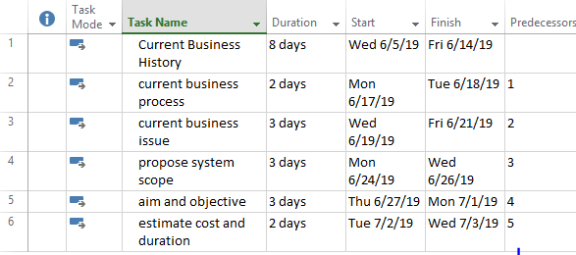

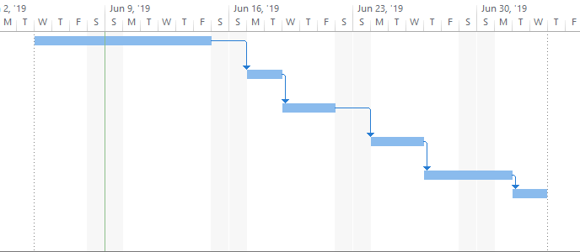

Chapter-1

Introduction

# 

# 1 Introduction

## 1.1 Background of the current system

### 1.1.1 Registration management

The registration form is requiring to take record about student. Including their name, age, address, phone number And Belts-ranking or are they new to this art. And they gave a small book in the fast day of school to student. Small note book was use to take record for student attendance. And they also asked which section you want to attend.

### 1.1.2 Attending management

Each student is given a small note book. Tracking the student attendance by taking the record on that notebook and also record in the school attendant file .They paper to take record. The attendance record is kept in the file and lock in the desk.

### section management

In the old system, the section divided into 3 section in total, the first section is for the early morning, this section mostly aim to people who are employee, some of them are kid but most are men who are employee, the second section is for the evening and the third section is for the late evening class held every day. The class will be divided into 4 section. first section is for the Early morning of Monday, Thursday and Friday. The second section is for the late evening of Monday, Thursday and Friday. And The third section is for the early morning for Saturday and Sunday. And the fourth section available evening for Saturday and Sunday. 1.2.4 Teacher management

## 1.1.4 Exam management

Like the other school. They need to produce graduate fighter. To develop graduate fighter. They test with the exam. The leader of the insulator asked the insulator for the student about are they ready for exam or not. If they are ready for exam. The leader of the insulator examines his student himself. But for the black belt exam the manager reports the main organization from the japan that some are ready for the examination. And also, the black belt is directly given by the examiner from the central organization.

## 1.1.5 Payment tracking

If the student put an attendance record book to accountant. The accountant gave attendance record and also record on the monthly payment tracking notebook. The payment tracking will be record in the long notebook including student name, student ID, phone number and their starting date. The monthly fee will be paid by 1 month after their starting date. Not monthly. If the student join in the 21 may. The monthly fee will be in the 21 June.

### 1.1.6 Fund management

Funding is the most importance thing to run the school the school got fund money by class monthly fee, student entrance fee and exam fee, they have the bank account and stored all the money in the bank. The bank account is control by the manager.

## 1.1.7 Tournament management

They heled a tournament in every year. The manager has to use fund more to rent the competition. Most students are participating in tournament. The tournament fight may be global or local. For the global fight the organization of the worldwide will be choose one country to heled the competition. If the competition will be held in other country. The manager has to pay flight fee for his fighter. And also, hotel fee.

## 1.2 Swot analysis (current system)

### 1.2.1 Strength

* Insulator have at least 10-year teaching experienced
* Head insulator have at least 20-year teaching experienced and 10 year studying experienced
* Having a team that is consider expert in the martial art industry

### 1.2.2 Weakness

* Dependence on quickly changing market lack
* Website at this time is under construction
* Lack of sufficient insulator during growth up
* As a new martial art school in this city

### 1.2.3 Opportunities

* School located in the populate area
* Local and global tournament fighting

### 1.2.4 Threats

* Dwindling local population
* A shortage of training equipment
* Student coercion to do thing they do not wish to do

## 1.3 Propose system scope

### 1.4.1 Registration

Students are required to sign a contract which contains their personal information like their name, address, phone number and date of birth. The method of gathering this information is by pen and paper and stored into computer database. And it also allows to choose section that student want to attend.

### 1.4.2 Attendance management

Use phone or tablet device to track attendance with app. Print QR code card directly from our software. I already give the copy QR code to student. Give a small note book to each of the student and take record in that card and scan their code to student database.

### 1.4.3 Payment tracking

The payment may be the 1 month after student start training date. The student start date and date for the end date will be saving in the student database. The student payment tracking will be linked with student id and name.

### 1.4.4 Exam management

The student needs to obtain approval from insulator who teaches him. All students will be encouraged to graduate as they progress and experience the art of martial art. Their attendance will be linked with their exam record according to their rank. The experiences insulator will be examining the student. For the black belt examination, if there more than 1 students who ready to take part in exam to a. And then the manager reported to the main organization from japan.

### 1.4.5 Class and section management

We can add as many sections as we like. But typically, main section will be divided into 2 sections, morning and evening. As we are available more than one course. We need more than one class. The low rank class, medium rank class and high rank class. The low rank class is the main class and the biggest class in the school. And this classes are the physical training class for all ranked. Classes will be held in Monday to Friday also include morning time and evening time. In the morning Monday all the student including low rank medium rank and high rank must come to main dojo to do physical training together. The evening is for the student from evening section. And they will do physical too. For the Thursday kata training will be held in their respective rank class. For the wed the physical training loop back and every student should come to main class. for the Thursday the technique training and also for Friday. And the evening section training is just like the morning.

### 1.4.6 Teaching management

The teaching management may be breaking down into three-part, physical training, kumite training and kata training. The physical training is more like GYM, unlike gym is training with the team. it helps student to gain more physical and to develop their body, the kumite training teaches them how to punch how to kick, how to fight, how to sparring, how to block. The word kata in Japanese means shape or form.

### 1.4 Aims and objective of the project

Improve the Student Enrollment System

In the old system the enrollment process is only complete by one stage and all of the data is saved by book which can lost easily.

In the new system I divided into two stages. For the stage one is only for the student information like student name, student age, date of birth,

And the second stage is which section student wants to enrolled and saved also the enroll Date

To improve the attendance tracking

In the old system attendance tracing only go with small attendance tracking book and some record with long book. The small book is owned by student and the long book is owned by the manger.

In the new system is used by the attendance tracker and can done only with fingerprint . Fingerprint are considered to be the best and fastest method for school. They are secure to use, unique for every person and does not change in one lifetime

## 1.5 Short overview of the remaining chapter

In this chapter, I describe the background of the current system. For the current system, include registration management, attending management, Class and section management, Exam management, fund management, tournament management. And I also describe the swot analysis for the current system. For the new system I describe registration, attendance management, payment management, exam management, class and section management and teaching management. And for the last I describe the aim and objective.

Chapter-2

## 2.1 Similar Product Comparison

I describe the student attendance tracking system from different websites

**Web A**

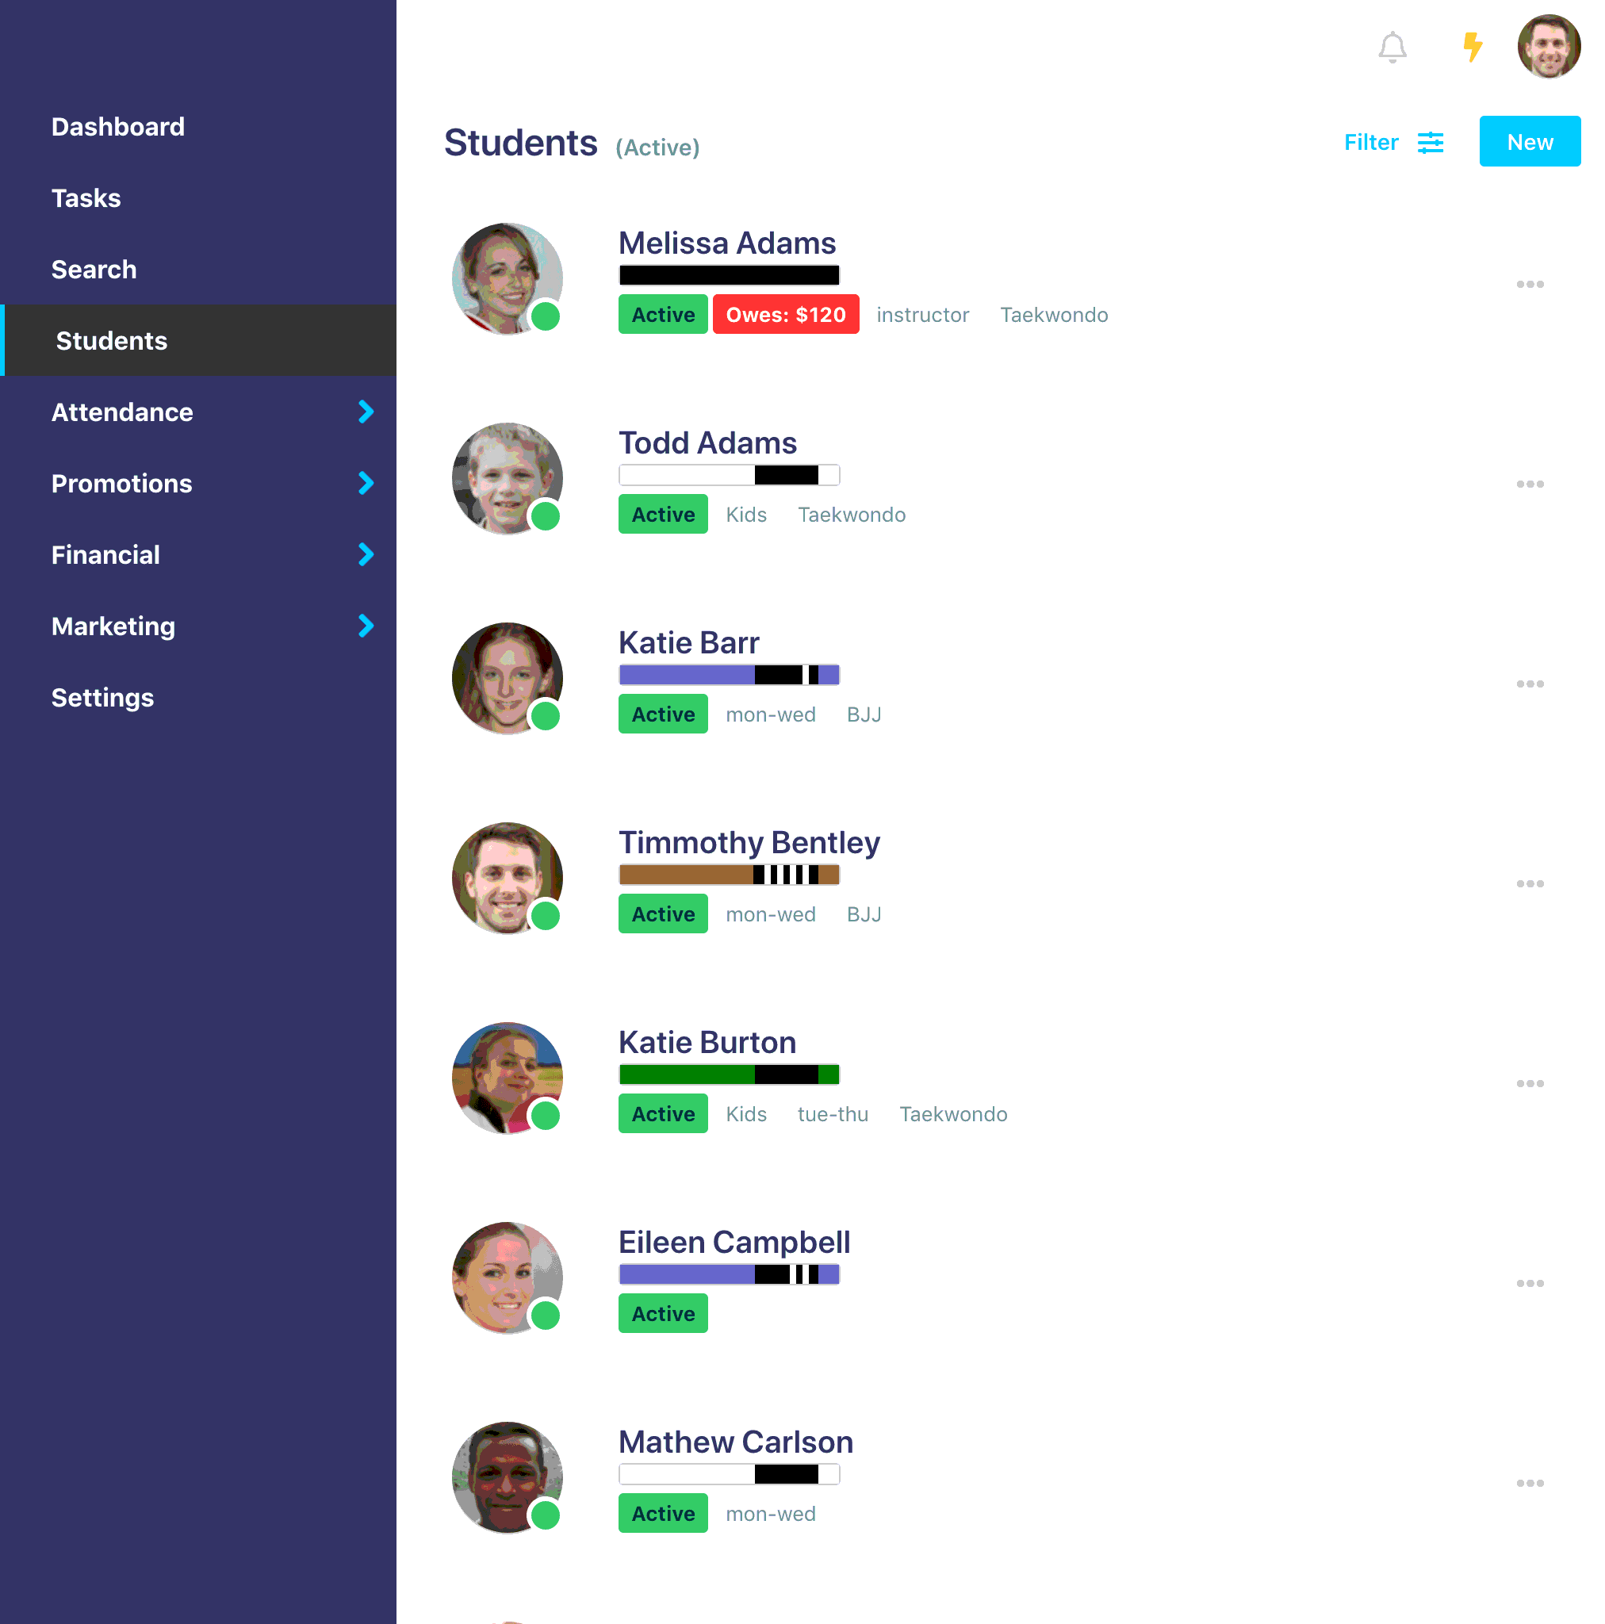

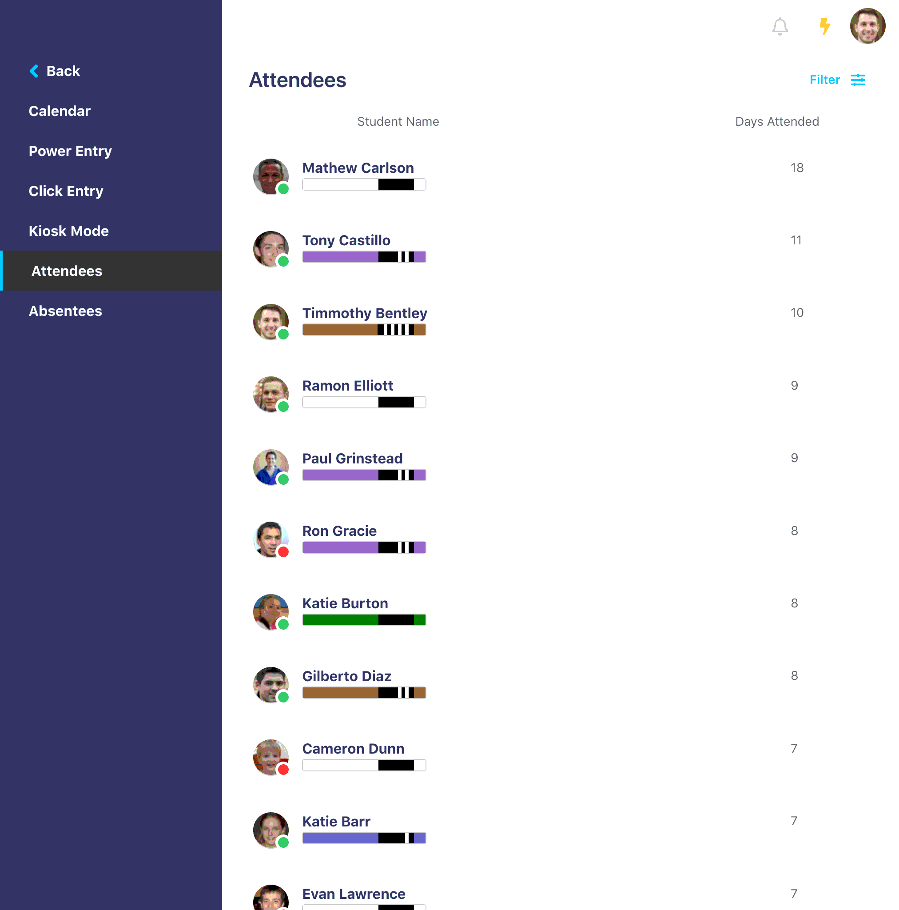

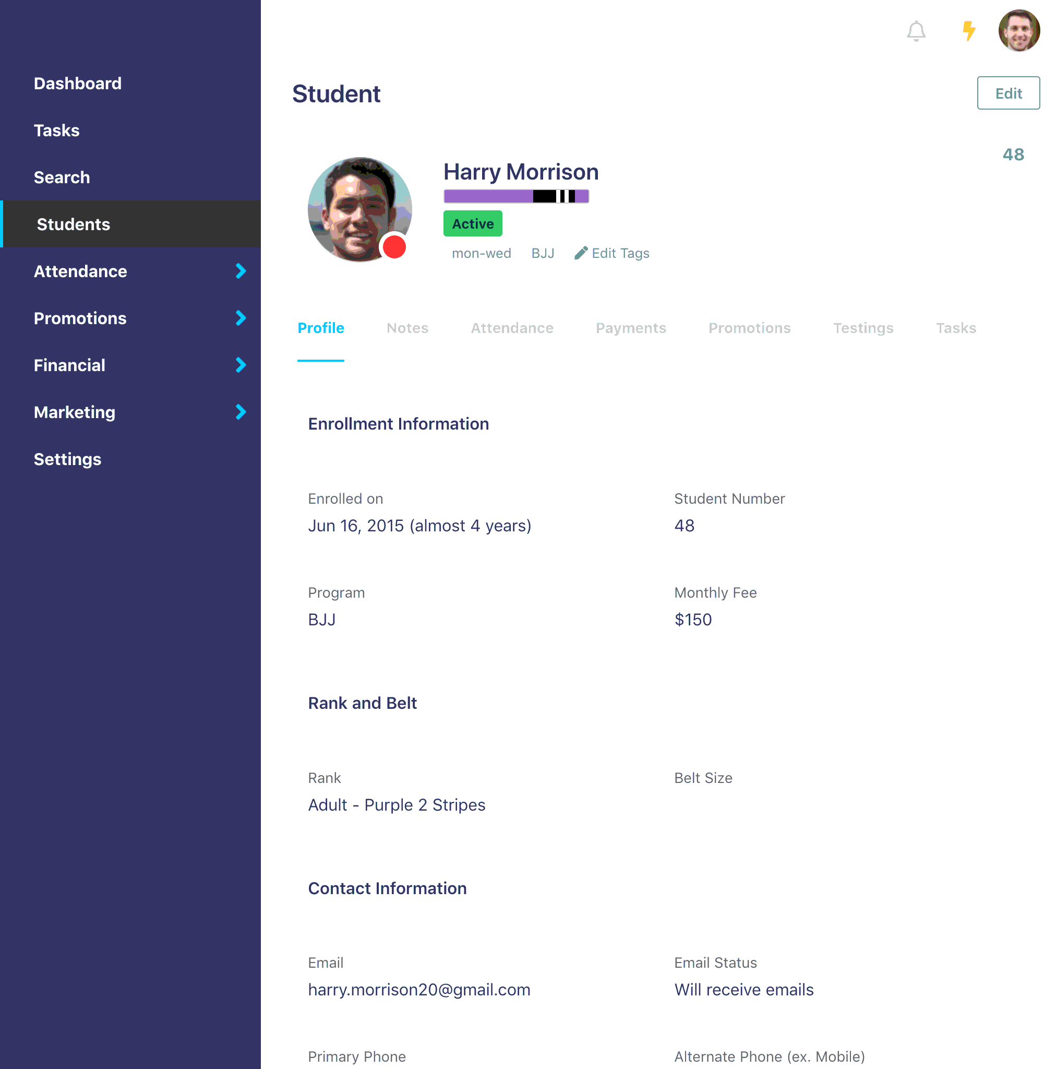





<https://martialarts.io/martial-arts-software/attendance>

Web B

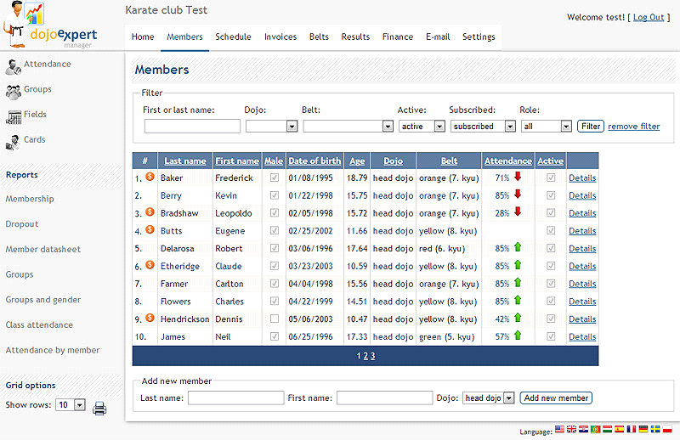

<https://www.capterra.com/p/130869/Dojo-Expert/>

## 2.2 functional comparison



Fig(1)



**Fig(2)**

 



**Fig (3)**

in the first form of fig (1) the manager can see their student name with their profile Picture. And their program, and their belt rank. Fig (1) is just a student profile and don’t include any attendance. In the fig (2) it also includes the attendance record, their name, their profile picture and their rank. In the fig (3) the manager can see their student fully information. The information divided into three parts the enrollment information, rank and belt and contact information. For the first is enrollment information including enrolled date, their student number, their program, their monthly fee. In the rank and belt information it includes only Rank and belt size. In the contact information it includes Email, and phone number. The manager can check in for the student who attend the class today for every day.

Fig (4)

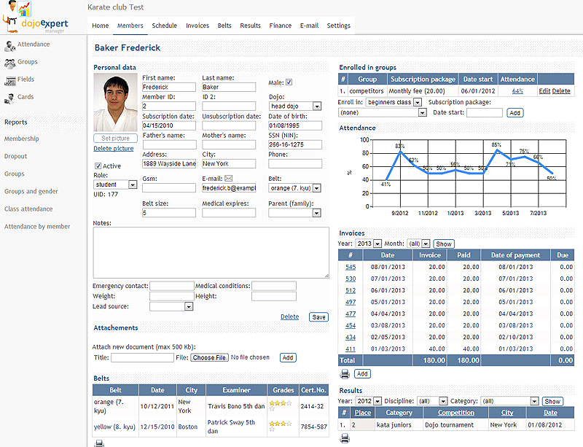

Fig (5)

In the second tracker of fig (1) the attendance manager can see their first name and last name, and their ID. The combo box will be correct if the student is male. And their Age. Their belt rank and attendance. If the student will be active for the class the manager will be click correct. In this tracker the manager can see their student attendance percentages. And there has an option called add a new member. The manager can add new member in this option. In the fig (5) the manager can see their member special information like their personal data, attachment, and belt enrolled in group, invoices and the last one is result.

#### Non-Functional Comparison

#### Visibility of systems status



Fig (7)



Fig (8)

The tracking system should always manager informed about the student attendance. In the first tracker software of fig (7) the manager can see how many days the student attend. And the matching of the student name and profile and the day attendance is seemed clearly.

And the student information seems clearly because It also include student information, Rank and belt and the contact info. In this form the manager can see clearly about student information and their name also include their program.

**User control and freedom**



Fig (9)



Fig (10)



Fig (11)



Fig (12)

In the first form the manager can click student profile to check the student information. As soon as the manager click the student profile picture or the student name as shown in fig (9). Their information will be shown as the fig (10).

The manager can see whatever he wants to see like student attendance, Students option as student information, promotions and marketing as shown in fig (11).

And the manager can also check in their student attendance as show in fig (12)

**Error Prevention**



**Fig (13)**



**Fig (14)**

Whatever the best attendance tracker it is, it’s still had error. that how error prevention occurs. In the fig (13) once the student joins the school and refill the registration from. and then the manager unfortunately gives him student id number that he already gives other and this can cause a lot of problem in student attendance.

And the manager forgets to take the check in for student that may cause student attendance problem. In the fig (14) it shows the student is successfully checking for their attendance.

**Recognition rather than recall**



In the fig (15) the manager can able to check in their student attendace by input some of the student name character whatever their fast or last two word of the surname or forename. It the manager input “he” in the search bar. The result will be uncountable it can be “Sherri Sullivan”, Joseph fisher, Darryl Wheeler ,Mathew Carlson, Dina Ccarruthers, Mithch Herman and so on , it will show every student it include he word in their fast or last name **.**

**Aesthetic and minimalist design**



**Fig (15)**

For example, in the first form of fig (15) under the belt ranking color, there has the active or inactive statues. If the student is active for the class. The active status will be show with green color. And the beside of profile picture. There has the dot with red color. It means the student is not active for that day the picture took. Or it may be the manager haven’t checked in for this student yet.

**Chapter-3**

**Feasibility Study**

## 3.1 technical feasibility

### 3.1.1 Methodologies

**A. Definition**

**Dynamic systems development method (DSDM)**

DSDM is an agile project delivery framework, initially used as a software development method. DSDM originally sought to provide some discipline to the rapid application development methods originally sought to provide some discipline to the rapid application development method. DSDM agile project framework was revised and become a generic approach to project management and solution delivery rather than being focused specifically on software development and code.

**Waterfall**

Waterfall model is a breakdown of project activities into linear sequential phases, where each phase depends on the deliverables of the previous one and corresponds to a specialization of tasks. The approach is typical for certain areas of engineering design. In software development, it tends to be among the less iterative and flexible approaches, as progress flows in largely one direction through the phases of conception, initiation, analysis, design construction, testing, development and maintenance.

**Strength and weakness of each Methodology**

**Strength of DSDM**

* High flexibility of the project
* High customer satisfaction
* Constant interaction
* Continuous quality assurance

**Weakness of DSDM**

* Difficult planning at early stages
* Lack of long-term planning
* relatively high barrier to entry
* switching to DSDM is neither cheap nor fast
* have not too much requirements for the quality of the product

**Strength and weakness of Waterfall methodology**

**Strength of waterfall methodology**

* Simple and easy to understand and use.
* Clearly-defined stages
* Provided requirements stability
* Lesser cost as planning overhead is less
* No planning needed
* Faster delivery of the project

**Weakness of waterfall methodology**

* All requirements are to be known upfront
* It is inflexible
* Longest tangible delivery time**.**
* Change can be costly
* Difficult to go back and change in testing stage

**C. Comparison of methodology**

|  |  |  |
| --- | --- | --- |
| **Criteria** | **DSDM** | **Waterfall** |
| Customer Availability | Prefers customer available through the project | Require customer involvement only at milestones |
| Feature | Can changes, but changes come at expensive cost. Work well when scope is not known in advance | Works well when scope is known in advance, or when contract term limit changes |
| Funding | Work extremely well with time & materials or other non-fixed funding , may increase stress in fixed-price scenariors | Reduce risk in firm fixed price comtraces by getting agreement up-front |
| Type | It separates the project development into sprints | Software development process is divided into distince phases |

**D. Recommendation**

DSDM method are more flexible than the waterfall method which mean that client request are more likely to be met. DSDM is to satisfy the customer and continues delivery of valuable software. And it can change requirement even late in development. But the waterfall cant do. And DSDM is beneficial for project where the end goal is not clearly defined. As the project progresses, the goal will come to light and development can easily adapt to these evolving requirements.

### 3.1.2 Programming languages

A. Definition

PHP

Php is a hypertext preprocessor is a general-purpose programming language originally designed for web development. Is a script language and interpreter that is freely available a used primarily on Linux web servers.

ASP.net

Asp.net is an open-source server-side web application framework designed for web development to product dynamic web pages. Is built on the common language Runtime, allowing

B. Strength and Weakness of each Programming languages

Strength of PHP

* Freely available all over the web
* Support database connectivity. Can access over 20 different databases.
* Can generate unique session
* Open source language
* Light weight language
* Eliminate client configuration problems
* Reduce development time
* Maintain source code security

Weakness of php

* Clint side scripting
* Sever slow down while multiple php applications are executed
* Error handling

Strength of asp.net

* Flexibility and object-oriented
* Mature Framework
* Reduce coding time
* World class toolbox
* High security feature

Weakness of asp.net programming language

* Expensive and their upkeep is resource intensive
* Core not good enough
* Porting ASP application from one server to another is expensive
* Making changes in the app

C. Comparison of programming language

|  |  |  |
| --- | --- | --- |
| **Criteria** | **Php programming language** | **Asp.net** |
| **Type** | Server-side scripting language | Server-side web application framework |
| **Speed** | Fast enough for desktop application | Not suitable and slower for desktop application |
| **Cost** | Freely available all over the web | License cost attached |
| **Security** | High secure | Less secure feature than asp.net |
| **Solution** | Focused on security and functionalities | Focused on Clint facing ,user interfaces |
| **Support** | Large to medium size enterprise application | Small to medium sized web solution |

**D. Recommendation for programming language**

The cost that php is free of cost and asp.net is a Microsoft product and hence come with certain changes. Php is one of the widely used scripting language and developer are addicted to it. PHP is inexpensive, secure, fast, and reliable. Php application can run on the various type of platform. PHP is supported by majority of operating systems. And it is widely used because it is easy to use.

### 3.1.4 Database

## Definition

**MySQL database**

MySQL is an oracle-backed open source relational database management system based on structured query language. Although it can be used in a wide range of application, my sql is most often associated with web applications and online publishing.

**Oracle database**

Oracle database Is a collection of data treated as a unit. The purpose of a database Is to store and retrieve related information. A database server is the key to solving the problems of information management

* **Strength and weakness of each database**

**Strength of MySQL**

* Data Security
* On-Demand Scalability
* High Performance
* Round-the-clock uptime
* Open source software

**Weakness of MySQL**

* Hard to scale
* Owned by oracle
* Not for large sized data

**Strength of oracle**

* Customer Satisfaction
* Improving database performance
* Grouping transaction
* Reliability
* Flashback technology
* Functionality

**Weakness of oracle**

* Cost
* Complexity
* **Comparison of Database**

|  |  |  |
| --- | --- | --- |
| Criteria | MySQL | Oracle |
| Cost | Open source and available for free download and installation | Only oracle express edition is free of cost. Oracle standard edition or oracle enterprise edition has to be purchased |
| User Authentication | Can be performed by using only location, username and password. | Performed by different authentication methods including database authentication, external authentication and proxy authentication. |
| XML | Does not support XML | Supports and uses XML |
| Support character type | Only support CHAR and VARCHAR | CHAR, VARCHAE, NCHAR, NVRCHAR2 |
| Audit vault facility | Dose not have audit vault feature in the server | Oracle provides audit vault facility |

**Recommendation**

MySQL is the open source when only oracle express edition is free to download and installation. MySQL is a lot easier to perform user authentication. MySQL can perform only using location, Username and password where the oracle performed by different

## 3.2 DSDM Feasibility

1. Focus on the business need

The project is to design and develop a similar system of school. First, we need to know how the school work. The client tell that he wants to develop the martials arts school which teaching karate. And then he changes to Mixed martial arts club that will teach a lot of course, karate, judo and etc.

2. Deliver on time

From the beginning to the end of the project. Our project will be divided into 3 Timebox. Each timebox for 4 months. Each timebox consist of functional requirement, use case diagram, class diagram and program. So, we need to finished all these requirements in just 4 months. Sometime the deadline even gets closer or later.

3. Collaborate

Involve the right people at the right time. Bring in SME’s and experts at points within the project when their experience can be best utilized. Actively involve business representatives. Gain business support through open communication. Invite business leaders to meetings and inquire about their thoughts on the current state and progress. Build a unified team through empowerment. Remove the top-down approach to project decisions. The project manager is there to serve as a guide to the process and a facilitator of communication, not the core decision make.

4. Never compromise quality

The tester tests the program code often. And sometime the Client want change eventually. So, the design needs to change the client need program code continuously. Build in quality at the beginning. Decide as a team the minimum level of acceptable quality. Test early, test often, test continuously. Test throughout the process to ensure quality is being met. Continuously review quality goals and current level of quality. Review with the team on a regular basis the current level of quality and the current quality goals. Adjust goals as needed, but never sacrifice quality for time or extra feature.

5. Build incrementally from firm foundations

Confirm that the solution is correct and meeting expectations. Hold conversations regularly to show the current solution state and allow for input from project stakeholders. Ensure the project is on the right path and adjust as needed. Adjust and re-assess priorities and project viability. Decide on and focus on the priorities needed to build a firm foundation. Building a firm foundation will more easily allow for expansion of the project later in other iterations of the development process. Recognize that change may occur, and adapt to it instead of fighting against it

6. Develop iteratively

Create the strong foundation. A strong solid base is easier to expand on later – you wouldn’t want to build a house on top of a broken foundation. Try new things or look at things from a different perspective. Take others suggestions into consideration. Recognize that the process is fluid and not locked in. Try things first, experiment, be open to changes. Allow detail to emerge later, rather than a strong detailed definition at the beginning. The project is being rough sketched in, as it progresses the sketch will become more detailed

7. Communicate continuously and clearly

Test early, test often, test continuously. Test throughout the process to ensure quality is being met. Continuously review quality goals and current level of quality. Review with the team on a regular basis the current level of quality and the current quality goals. Adjust goals as needed, but never sacrifice quality for time or extra feature.

8. Demonstrate control

Take others suggestions into consideration. Try new things or look at things from a different perspective. Take others suggestions into consideration. Review with the team on a regular basis the current level of quality and the current quality goals. Try new things or look at things from a different perspective. Take others suggestions into consideration. Recognize that the process is fluid and not locked in. Try things first, experiment, be open to changes

(8 principle of Dsdm, n.d.)

**Chapter-4**

**Foundation**

# 

## 4.1 Target User

Target User are every age but must older than 18 years

|  |  |  |  |
| --- | --- | --- | --- |
| **Type of User** | **Age** | **Computer skill / IT Literacy** | **Language skill**  **(especially English skill)** |
| Staff | 20 | Microsoft word, Microsoft, Excel | need |
| manager | 40 | Business management | need |
| accountant | 25 > age | Expert at MySQL and oracle  And another database software | No need |
| instructor | 21<age<60 | Have more than 1 years teaching experiences | need |

# Functional Requirement

1. Manage Enrollment process
   1. Manage Course
      1. Register Course
      2. Update Course
      3. Delete Course
      4. View Course
   2. Manage Section
      1. Register Section
      2. Update Section
      3. Delete section
      4. View Section
   3. Manage Student
      1. Register Student
      2. Update Student
      3. Delete Student
      4. View Student

## 4.3 MOSCOW Prioritization

**Must**

|  |  |  |  |  |
| --- | --- | --- | --- | --- |
| **High Level Requirement list** | **Must** | **Should** | **could** | **would** |
| Manage Course | ✓ |  |  |  |
| Manage Section |  | ✓ |  |  |
| Manage student |  |  | ✓ |  |

**MOSCOW justification**

**Must**

**Manage Course**

Manage Course Is an important thing in the system. Because if there was no course. The section won’t work. If there is no section. No student can make enrollment.

**Should**

**Manage Section**

After Managing Course. The section can now register. Depend on the course. Single course can now have different section.

**Could**

**Manage Student**

After section register. The student can enroll the section.

## 4.4 Non-Functional Requirements

### Usability

Usability is the ease of use and learnability of a human-made object such as a tool or device. In [software engineering](https://en.wikipedia.org/wiki/Software_engineering), usability is the degree to which a software can be used by specified consumers to achieve quantified objectives with effectiveness, efficiency, and satisfaction in a quantified context of use Security

### Performance

It is any quantitative metric for the system to meet. Performance is generally per perceived as a time exception. This is one of the most important considerations especially when the project is in the architecting phase. Choosing the right technology is crucial at this point

### Interface

An interface requirement is a system requirement that involves an interaction with another system. The format of the interface requirement is such that it includes a reference to the specific location in the definition document that defines the interface.

### Recovery

The system should be responsible to taking backups of data, such that it may be restored backup data very frequently to avoid any data loss. The system should backup in a short period of time with minimal disruption. Recovery requirements typically are broken down by functional areas.

## 4.5 Time box Plan

### Time box 1: Manage enrollment process

|  |  |  |  |
| --- | --- | --- | --- |
| **Time box Name** | | Manage enrollment process | |
| **Start Date** | | September 5 , 2019 | |
| **End Date** | | September 26,2019 | |
| **Task** | **Duration** | **Start Date** | **End Date** |
| Functional Requirement | 1 day | Sep 5, 2018 | Sep 5, 2018 |
| Use Case Diagram | 1 day | Sep 6, 2018 | Sep 6, 2018 |
| Class Design | 1 days | Sep 7, 2018 | Sep 7, 2018 |
| Sequence Diagram | 1 days | Sep 8, 2018 | Sep 8, 2018 |
| High Level & Low-Level Prototype | ?? | ?? | ?? |
| Coding | 10 days | Sep 9, 2018 | Sep 20, 2018 |
| Functional Testing | 2 days | Sep 21, 2018 | Sep 23, 2018 |
| Usability Testing | 2 days | Sep 24, 2018 | Sep 25, 2018 |
| Time Box Summary | 1 day | Sep 26, 2018 | Sep 26, 2018 |
| **Key Deliverables (Output)**  **Design**   * Use Case Diagram for enrollment Process * Class diagram for enrollment process   **Coding**  Register student  Update student  Delete student  View student  Register section  Update section  Delete section  View section  **Testing**   * Unit Test Document * Usability Test Document * Test Cases | | | |

### Time box 2: manage Schedule process

|  |  |  |  |
| --- | --- | --- | --- |
| **Time box Name** | | Manage Schedule Process | |
| **Start Date** | | December 21, 2019 | |
| **End Date** | | XXXXXXXXX | |
| **Task** | **Duration** | **Start Date** | **End Date** |
| Functional Requirement | 1 day | Sep 5, 2018 | Sep 5, 2018 |
| Use Case Diagram | 1 day | Sep 6, 2018 | Sep 6, 2018 |
| Class Design | 1 days | Sep 7, 2018 | Sep 7, 2018 |
| Sequence Diagram | 1 days | Sep 8, 2018 | Sep 8, 2018 |
| High Level & Low-Level Prototype | 2 days | Sep 9 | Sep 10 |
| Coding | 10 days | Sep 11, 2018 | Sep 21, 2018 |
| Functional Testing | 2 days | Sep 21, 2018 | Sep 23, 2018 |
| Usability Testing | 2 days | Sep 24, 2018 | Sep 25, 2018 |
| Time Box Summary | 1 day | Sep 26, 2018 | Sep 26, 2018 |
| **Key Deliverables (Output)**  **Design**   * Use Case Diagram for enrollment Process * Class diagram for enrollment process   **Coding**  Register student  Update student  Delete student  View student  Register section  Update section  Delete section  View section  **Testing**   * Unit Test Document * Usability Test Document * Test Cases | | | |

### Time box 3: XXX

## 

## 4.6 Risk Management

Risk management within schools is a rather complex concept, which is comprised of several functions. It is the “process of managing uncertainty of exposures that affect a school district’s assets and financial statements using the five steps: identification, analysis, control, financing and administration.” As indicated in the definition, it extends far beyond the funding or financing of losses through transfer of risk or insurance. The most important part of risk management within schools is risk identification. Whether risks are human in nature, or are related to property or liability, they must be identified first. An exposure and/or risk must be identified before it can be effectively analyzed, controlled, or financed. Finding the hole in the gymnasium floor, or slippery surface in the high school stairwell, leaky roof from the recent storm, or finding holes in coverage in construction contracts for exposures are all part of identifying risks within schools. Risk identification is a time-consuming process, which commonly includes checklists, contract reviews and loss data collection. However, it is the only way to effectively understand and manage all the risks’, who is ultimately responsible for effective risk management within a school district? The answer is becoming more and more elusive as job functions change daily to accommodate the doing-more-with-less funding attitudes and issues from state to state. The most obvious answers are the safety coordinator, financial department and human resources area. The true answer is, everyone. A team of people should always be responsible and accountable to a set of specific risk management policies and procedures. All department heads food service, custodial, maintenance and operations, instructional need to be in the loop and should be managers of risk in a school district. The risk management function can be assumed by people regardless of the size and needs of the school district. Even if your school has a dedicated risk manager, he or she should rely on many internal and external people and resources to effectively manage the district’s daily risks.

### 4.6.1 Identification of Possible Risks

#### 4.6.1.1 Virus Threat

This risk can happen most in our project because we are working our project in computer. If it does, it will have more effect than any other.

#### 4.6.1.2 Team member experiences

This project is working with team. In addition, we need to work with someone who does not know through the project until the end of the project.

#### 4.6.1.3 Computer Crash

Computer can be crash. Sometime errors in the operating, software or errors in the computer hardware. After working a lot of times, the central processing unit can also be the source of crashes due to excessive heat.

#### 4.6.1.4 Environment Risk

As we are working our project on earth. The fire threat, water threat or etc. After working our project, a lot, we can easily lose our data. IF it happens, we have to start our project form the beginning.

### 4.6.2 Critical Success Factors for current project

To finished the project successful, we need to follow the rule that the company was written. The design needs to create the best design as he can. The programmer needs to develop the best version of the program. And the tester needed to test what programmer create. To develop the best of the program, the company need to choose the programmer seriously. The design is base of the project. The design will divided into use case

### 4.6.3 Risk Matrix

|  |  |  |  |  |  |
| --- | --- | --- | --- | --- | --- |
| **Risk** | **Probability** | **Impact** | **Proactive Action** | **Reactive Action** |  |
| Not enough experience | high | Medium | Learn about business process and discussion with the user | Discuss with supervisor about project | Team member |
| Virus Threat | medium | high | install anti-virus and discuss with security expert. getting backup all data | meet with virus experts | Security |
| team member experiences | high | medium | Discus before work | Attend the seminar every week | Project manager |
| computer crash | high | low | Update virus protection software on a regular basis. Back-up files frequently. ... | Restart computer  Install anti-virus and discuss with computer expert | Computer it professional |
| Environment Risk | high | low | Backup the data |  | Project manager |

### 4.6.4 Social legal ethical professional issues

**Legal**

The school owner

**Social**

**Ethical**

**professional**

**Chapter-5**

**Exploration & Engineering**

## 5.1 Time-box 1: Enrollment Time-box Development

## Project Plan for Time Box 1

### 5.1.1 Functional Requirements

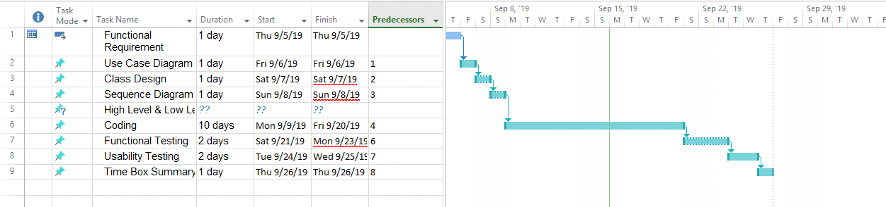

1. manage enrollment process
   1. manage Course
      1. Register Course
      2. Update Course
      3. Delete Course
      4. View Course

1.2

1. Manage enrollment process
   1. Manage Course
      1. Register Course
      2. Update Course
      3. Delete course
      4. View Course
   2. Manage Section
      1. Register Section
      2. Update Section
      3. Delete Section
      4. View Section
   3. Manage Student
      1. Register Student
      2. Update Student
      3. Delete Student
      4. View Student

5.1.1 Class diagram for enrollment process 

## 5.1.2 Use Case Diagram for enrollment process



# Use Case Description

|  |  |
| --- | --- |
| **Use Case Name** | Register Course |
| **Actor** | staff |
| **Flow of Event** | Fill the Course Detail in the register from and register button is clicked |

|  |  |
| --- | --- |
| **Use Case Name** | Register section |
| **Actor** | Staff |
| **Flow of Event** | Fill the Course Detail in the register from and register button is clicked |

|  |  |
| --- | --- |
| **Use Case Name** | Register Student |
| **Actor** | staff |
| **Flow of Event** | Fill the Course Detail in the register from and register button is clicked |

## For remaining, see Appendix.

## Screen Design

### Student Registration Form

### Course Registration Form

### Section Registration Form

## 

## Low level and high-level prototype

### Fig (1) Low Level Prototype for Student Registration

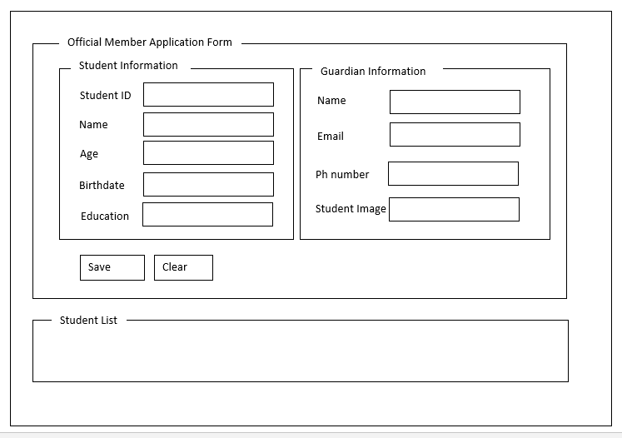

### Fig (2) High Level Prototype for Student Registration

### Fig (3) low Level prototype for course Registration

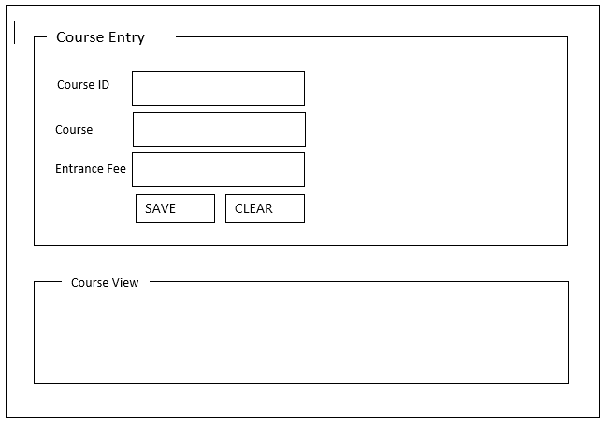

### Fig (4) High level prototype for course Registration

### Fig (5) Low level Prototype for Section Registration

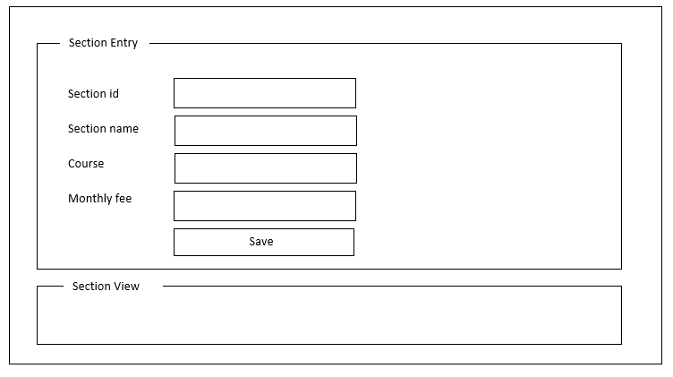

### Fig (6) High level prototype for Section Registration

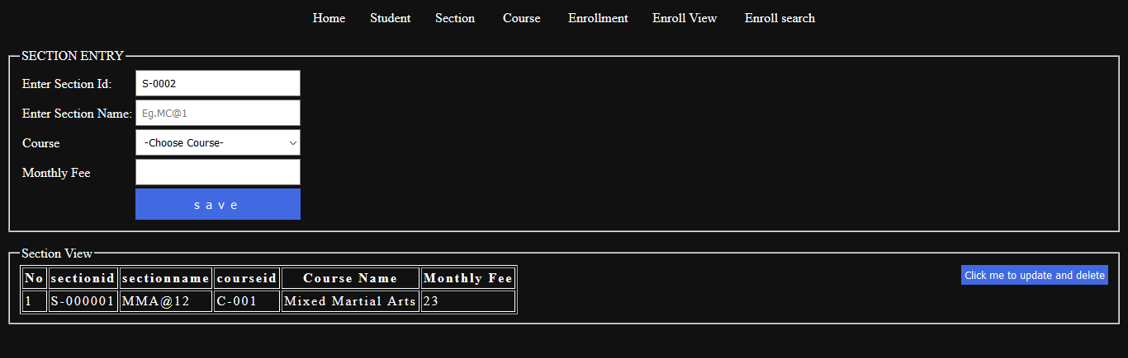

## 5.1.4 Iteration for Screen Design

#### Iteration 1

In this first I crate the student registration form with a few requirements. But the client was not satisfied at all. And he tells that the form requires not only name and age but also need the education level and birthdate in the student registration form.

#### (Iteration 1) Screen Design for Student Register Form

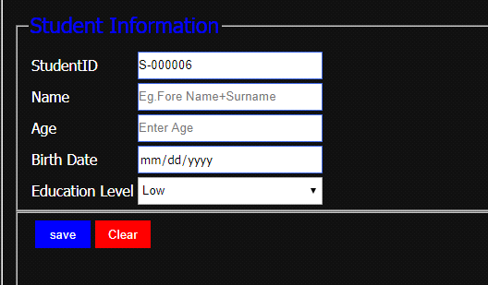

#### Iteration 2

User tells that student Name Placeholder needed to change from “eg. fore name surname” to “Student Name Is require”.

#### (Iteration 2) Screen Design for Student Register Form

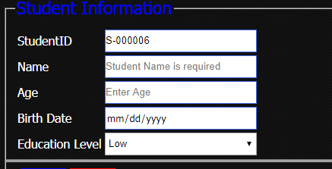**s**

#### Iteration 3

User tells that Email needed to change from “enter email address” to “Email is require”.

#### (Iteration 3) Screen Design for Student Register Form

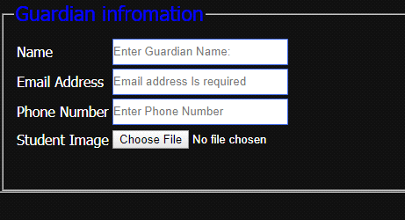

#### Iteration 4

User tells that Email needed to change from “enter email address” to “Email is require”.

#### (Iteration 4) Screen Design for Student Register Form



### 5.1.5 Class Diagram

#### Initial Class Diagram

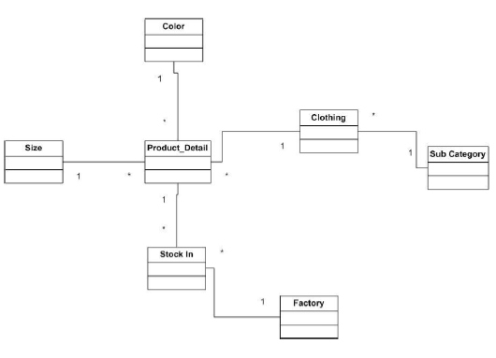

#### Detailed Class Diagram

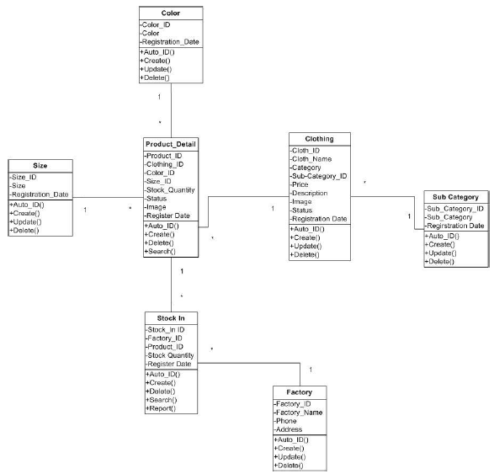

#### Detail Class Definitions

|  |  |
| --- | --- |
| **Class Name** | student |
| **Attributes** | Studentid, name1, age, birthdate, education, name2, email, phone number, student image. |
| **Operation** | Register (),Cancel (), AutoID(), Checkdata(),Update(), delete() |
| **Description** | << The **Student** class is used to do register for student who want to make enrollment. |

|  |  |
| --- | --- |
| **Class Name** | Couse |
| **Attributes** | Courseid, coursename, coursefee |
| **Operation** | Register (), AutoID(), update(), delete() |
| **Description** | << The **Student** class is used to do register for student who attended.>> |

For remaining, see Appendix.

### 5.1.6 Sequence Diagram for Enrollment Process



### 

**Sequence Diagram Description**

### 5.1.7 Functional Testing

#### Test Plan

**Module 1: Student Entry**

|  |  |  |  |
| --- | --- | --- | --- |
| Test Script | Description | Date | Tester |
| 1 | Test Auto id for student ID | 27- September- 2018 | Moe Khant Zaw |
| 2 | Test the data can’t be save if the importance data is missing | 7- August- 2018 | Moe Khant Zaw |
| 3 | Test the ‘@’ in the E mail | 7- August- 2018 | Moe Khant Zaw |
| 4 | Test Register Button is really work and the data can be really saved | 7- August- 2018 | Moe Khant Zaw |

***Test Script (1)***

|  |  |  |  |  |
| --- | --- | --- | --- | --- |
| **Unit Test 1** | | **Test Case:** Register by data entry student | **Designed by:** Moe Khant Zaw | |
| **Data Source:** student register Form | | **Objective**: To test the Register of data entry student | **Tester**: Moe Khant Zaw | |
| **Test Case** | **Description** | **Test Procedure** | **Expected Result** | **Actual Results** |
| 1.1 | Test Auto id for student ID | Test the student auto id is really work | Auto id is increase by 1 after student is register | See Fig.1.2 |

Before Testing

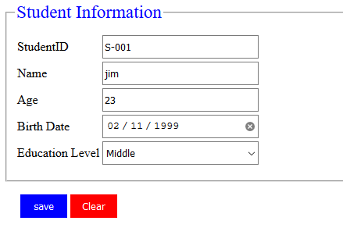

Fig.1.1

After Testing

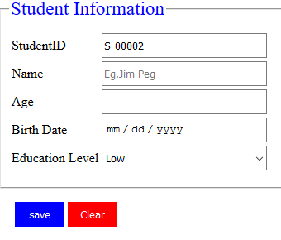

Fig.1.2

***Test Script (2)***

|  |  |  |  |  |
| --- | --- | --- | --- | --- |
| **Unit Test 2** | | **Test Case:** Register by data entry student | **Designed by:** Moe Khant Zaw | |
| **Data Source:** student register Form | | **Objective**: To test the Register of data entry student | **Tester**: Moe Khant Zaw | |
| **Test Case** | **Description** | **Test Procedure** | **Expected Result** | **Actual Results** |
| 2.1 | Testing the complete Register of data entry sstudent | 'Register' button is clicked importance data is missing | Show ‘Please fill out this field’ message. | See Fig.2.2 |

Fig (2.1)

Before Testing

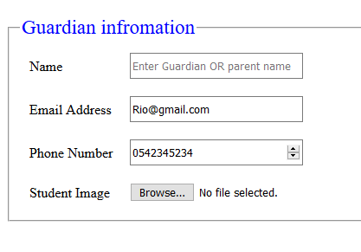

After Testing

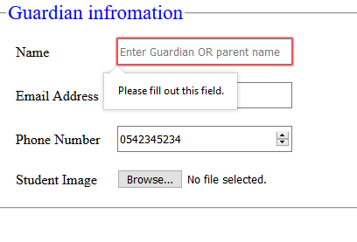

Fig(2.2)

***Test Script (3)***

|  |  |  |  |  |
| --- | --- | --- | --- | --- |
| **Unit Test 3** | | **Test Case:** Register by data entry student | **Designed by:** Moe Khant Zaw | |
| **Data Source:** student register Form | | **Objective**: to test the email | **Tester**: Moe Khant Zaw | |
| **Test Case** | **Description** | **Test Procedure** | **Expected Result** | **Actual Results** |
| 3.1 | Testing the complete Register of data entry student | 'Register' button is clicked. Guardian Email is unformat. | Show ‘Please fill out this field’ message. | See Fig.3.2 |

Before Testing

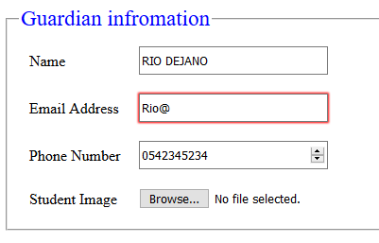

Fig (3.1)

After Testing

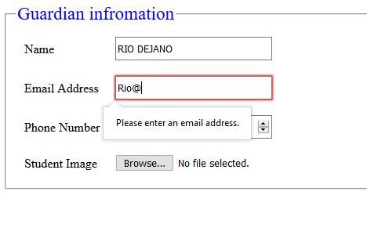

Fig (3.2)

***Test Script (4)***

|  |  |  |  |  |
| --- | --- | --- | --- | --- |
| **Unit Test 4** | | **Test Case:** Register by data entry student | **Designed by:** Moe Khant Zaw | |
| **Data Source:** student register Form | | **Objective**: to test the register button | **Tester**: Moe Khant Zaw | |
| **Test Case** | **Description** | **Test Procedure** | **Expected Result** | **Actual Results** |
| 3.1 | Testing the complete Register of data entry student | 'enter all requirement data and click register button,. | The data will be stored in the database | See Fig.4.2 |

Before Testing

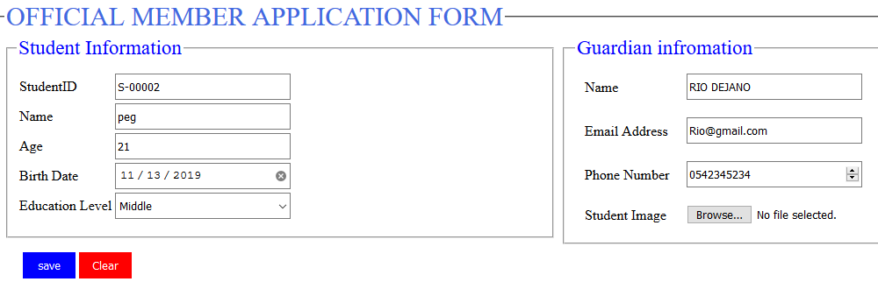

Fig (4.1)

After Testing

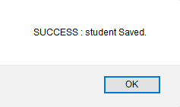

Fig (4.2)

**Module 2: Course Entry**

|  |  |  |  |
| --- | --- | --- | --- |
| Test Script | Description | Date | Tester |
| 1 | Test Auto id for course ID | 5-Janrary-2020 | Moe Khant Zaw |
| 2 | Test the data can’t be save if the importance data is missing | 7- August- 2018 | Moe Khant Zaw |
| 3 | Test Register Button is really work and test the data can be really saved to the database | 7- August- 2018 | Moe Khant Zaw |

***Test Script (1)***

|  |  |  |  |  |
| --- | --- | --- | --- | --- |
| **Unit Test 1** | | **Test Case:** Register by data entry course | **Designed by:** Moe Khant Zaw | |
| **Data Source: Course** register Form | | **Objective**: To test the Register of data course entry | **Tester**: Moe Khant Zaw | |
| **Test Case** | **Description** | **Test Procedure** | **Expected Result** | **Actual Results** |
| 1.1 | Test auto id for course id | Register button is clicked after enter all the information the database need. | Course id is add by 1 after saved | See Fig.1.2 |

**Before testing**

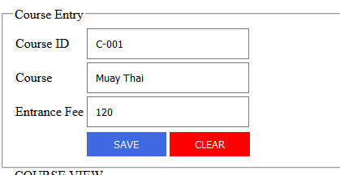

**Fig (1.1)**

**After Testing**

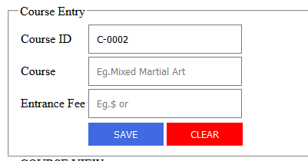

**Fig (1.2)**

***Test Script (2)***

|  |  |  |  |  |
| --- | --- | --- | --- | --- |
| **Unit Test 2** | | **Test Case:** Register by data entry course | **Designed by:** Moe Khant Zaw | |
| **Data Source:** student register Form | | **Objective**: To test the Register of data course entry | **Tester**: Moe Khant Zaw | |
| **Test Case** | **Description** | **Test Procedure** | **Expected Result** | **Actual Results** |
| 1.1 | Test the data can’t be save if the importance data is missing | Register Button is click | Show ‘Please fill out this field’ message. | See Fig.2.2 |

**Before testing**

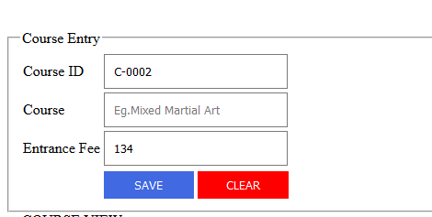

**Fig (2.1)**

**After Testing**

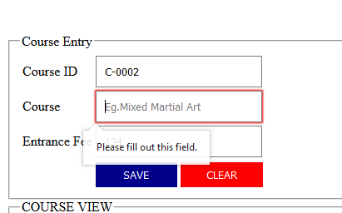

**Fig (2.2)**

***Test Script (3)***

|  |  |  |  |  |
| --- | --- | --- | --- | --- |
| **Unit Test 3** | | **Test Case:** Register by data entry course | **Designed by:** Moe Khant Zaw | |
| **Data Source:** student register Form | | **Objective**: To test the Register of data course entry | **Tester**: Moe Khant Zaw | |
| **Test Case** | **Description** | **Test Procedure** | **Expected Result** | **Actual Results** |
| 1.1 | Test Register Button is really work and test the data can be really saved to the database | Register Button is click | The data will be saved and stored in the database | See Fig. 3.2 |

**Before testing**

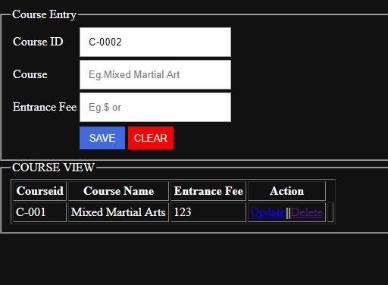

**Fig (3.1)**

**After Testing**

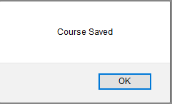

**Fig (3.2)**

**Module 3: Section Entry**

|  |  |  |  |
| --- | --- | --- | --- |
| Test Script | Description | Date | Tester |
| 1 | Test Auto id for section ID | 5-Janrary-2020 | Moe Khant Zaw |
| 2 | Test the data can’t be save if the importance data is missing | 7- August- 2018 | Moe Khant Zaw |
| 3 | Test Register Button is really work and test the data can be really saved to the database | 7- August- 2018 | Moe Khant Zaw |

***Test Script (1)***

|  |  |  |  |  |
| --- | --- | --- | --- | --- |
| **Unit Test 1** | | **Test Case:** Register by data entry section | **Designed by:** Moe Khant Zaw | |
| **Data Source: section** register Form | | **Objective**: To test the Register of data section entry | **Tester**: Moe Khant Zaw | |
| **Test Case** | **Description** | **Test Procedure** | **Expected Result** | **Actual Results** |
| 1.1 | Test auto id for course id | Register button is clicked after enter all the information the database need | section id is add by 1 after saved | See Fig.1.2 |

**Before testing**

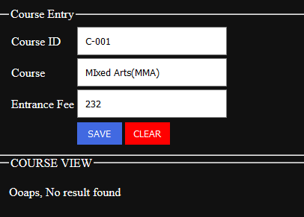

**Fig (1.1)**

**After Testing**

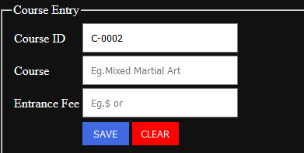

**Fig (1.2)**

**5.1.8 Usability Testing**

***Visibility of System Status***

Can easily see the input box which user are trying to input

Student register ,course register ,section register and etc,

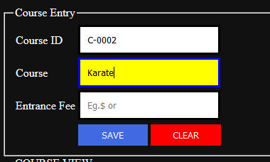

Hover effect that user can easily seen

Explain

In this program I used hover effect for the one that user focusing. For the result the user can easily see what he really inputting.

***Match between System and Real World***

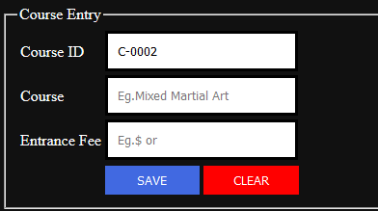

Explain

The input place holder will let the user know that what he needs to enter. That will really work if user don’t know what he needs to enter

FASDF

***Aesthetic and Minimalist Design***

ASDF

***Consistency and standard***

***Error Prevention***

The message box will be appearing if the user types the unformat email address and the border color will be change to red.

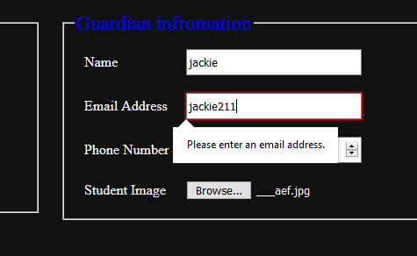

The message box and the border effect

Explain

In this program I write the email address input type code as email. So, it will automatically show these things.

***User Control and Freedom***

ASDF

**5.1.9 Iteration for Usability Testing**

**Iteration 2**

Users tell that table form and room form design are needed to change. So, table style combo box is added in table entry form and room size combo box and Facility text box is also added in room form.

**(Iteration 2) Iteration For Visibility of System Status**

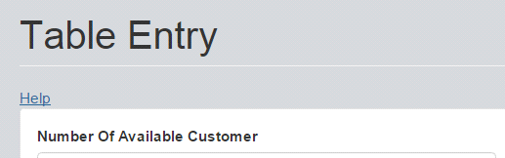

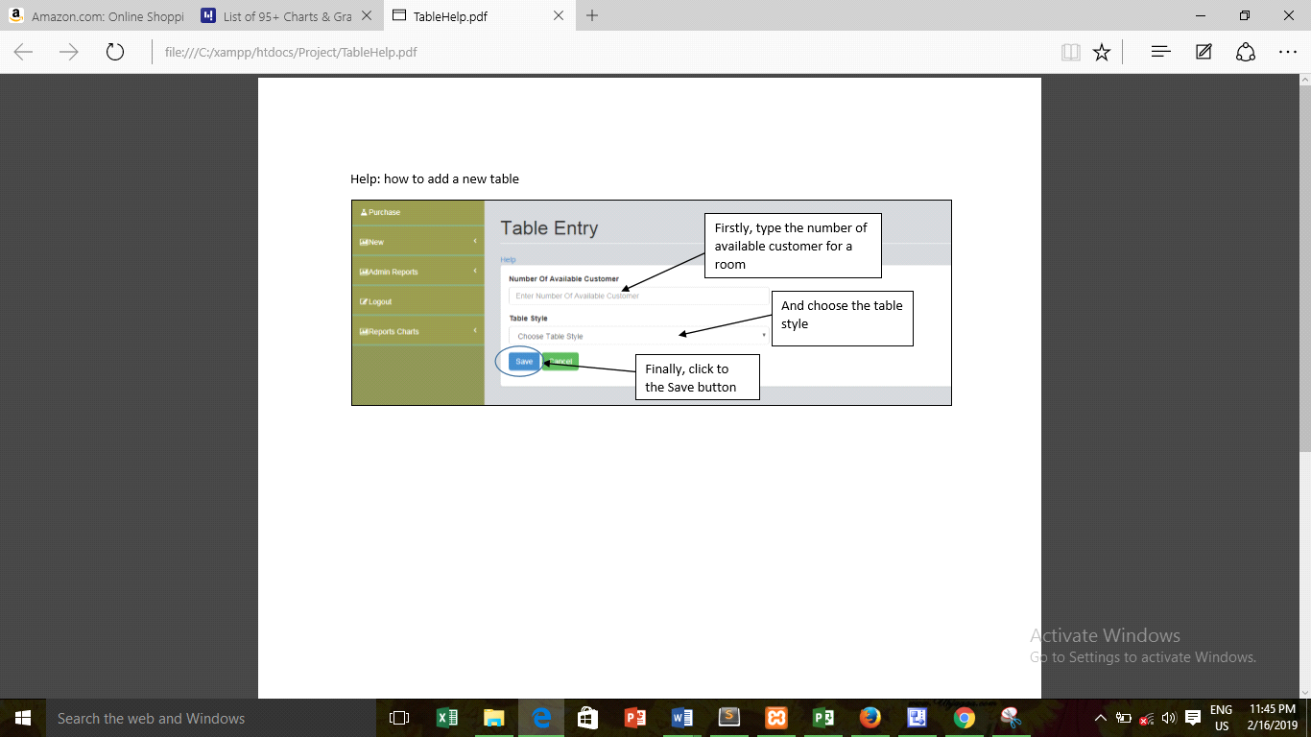

**5.1.8 Time box Summary**

describe the complete timebox

Example. Course, section

Time box problem

Time box 1 issues

Problem Solve

Lesson learns

**Chapter-6**

**Exploration & Engineering**

# Data Migration

Data migration is known as transferring data from one system to another modern system And Also known as transferring application from older to newer

Generally, introduction the old data to new system or new application.

in old system they used to work with manual system. And I have been asked to upgrade the system.

There are three type of data migration

(1) DataBase Migration

(2) Cloud Migration

(3) Application Migration

firstly, i will introduce about storage migration.

Database is the process of changing data and upgrading database and moving data into cloud

Storage migration is the storage that really look like array, the process of storage migration is moving data from existing array to modern one that can enable other system to access

Application migration is the process of switching form old application to new application.

(education, 2019)

1. Evaluation against Aims and Objectives

- Aims and Objectives

- What have been done

- Problems Encountered

- Lessons Learnt

2. Evaluation against Similar System Comparison

- Functional Comparison

- Usability Comparison

3. Evaluation of the System against Possible Legal, Social, Ethical Issues

- Issues Identified

- Whether they are solved or not

- Problems Encountered

- Lessons Learnt

4. Evaluation against Justifications Made

• Language

- Selected Languages

- Problems Encountered

- Lessons Learnt

• Database

- Selected Database

- Problems Encountered

- Lessons Learnt

• Methodology

- Selected Methodology

- Problems Encountered

- Lessons Learnt

5. Evaluation against Project Plan

- Whether the project is on track with the plan

- What was complete on time

- What was not complete on time and why

- Lessons Learnt

6. Future Amendments

- Program

- Design

- Report

**References**

**References List**

**Appendix**

# User Guide